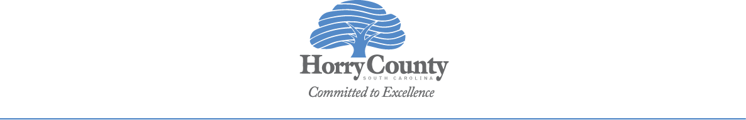  Horry County Government  Community Development & Grants Department  www.horrycounty.org |  | Community Development and Grants  100 Elm Street  Conway, South Carolina 29526  Phone 843.915.7033 || Fax 843.915.6184

Public Notice
Released August 5, 2025

Horry County Government was notified via the Federal Register on August 5, 2025 that the County is eligible to apply to the U.S. Department of Agriculture (USDA) for funding under the Housing Preservation Grant Program. Horry County intends to apply for a $150,000 grant to provide emergency and/or preservation repairs to eligible low income and very low income households located within eligible rural unincorporated areas of Horry County. The statement of activities is available for review and comment online at https://www.horrycountysc.gov/departments/community-development/public-notices. Questions and comments concerning this grant should be directed to Elizabeth Tranter, Director, at the above address, by email at tranter.elizabeth@horrycountysc.gov, or by phone at 843-915-7036.

