Scheduling Your HRA
Annual Health Risk Assessments (HRA) are now available throughout the calendar year at multiple locations. To schedule, please follow the below instructions. For help, please contact Human Resources @ 843.915.5230

- To access the scheduling platform, please post below link into your URL, or scan the QR code with your smart phone:

 Calendly - Horry County

- Choose your location of choice and select the arrow to the right of the location.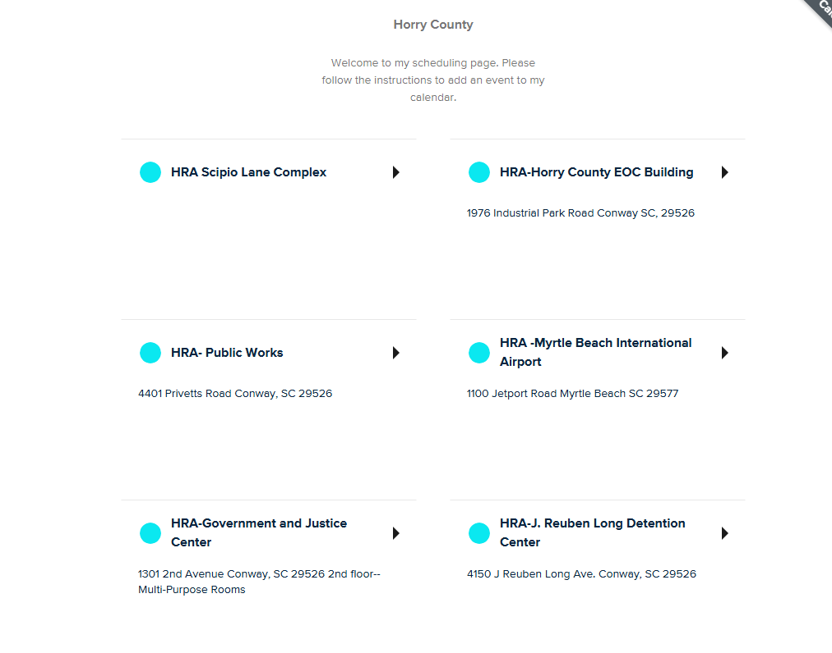t:
3.) Available dates are highlighted-select the date, or use the arrows to look to future dates: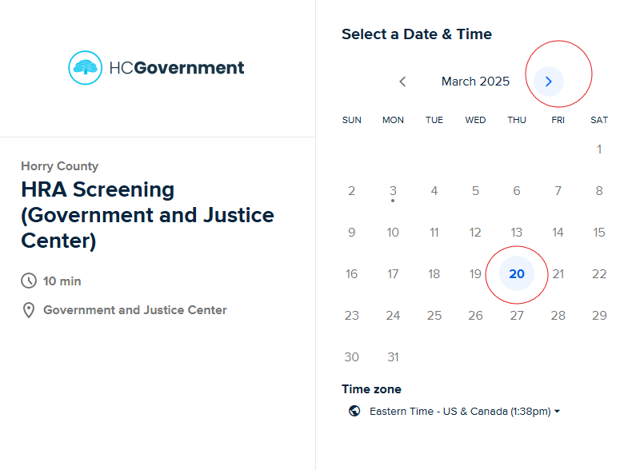

- Select a time slot and then select “next”:
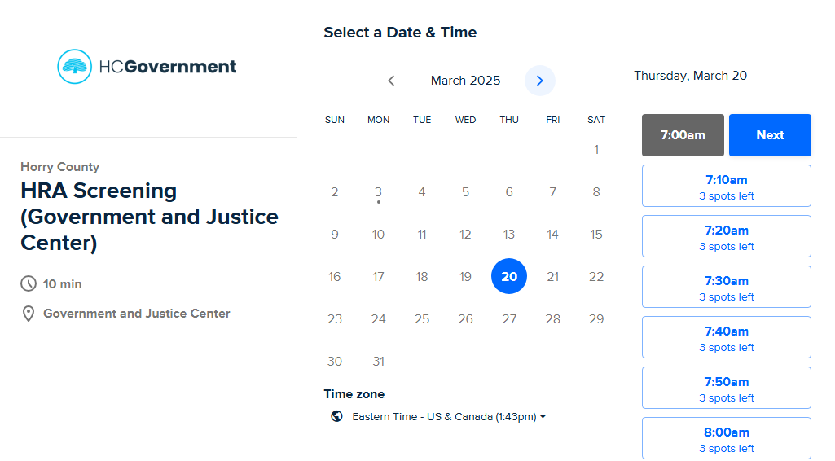

- Enter detailed information. Please enter the email you would like confirmations and reminders to be sent. Please enter a phone number that you wish to have confirmation text reminders to be sent.
Then select, “schedule event.”

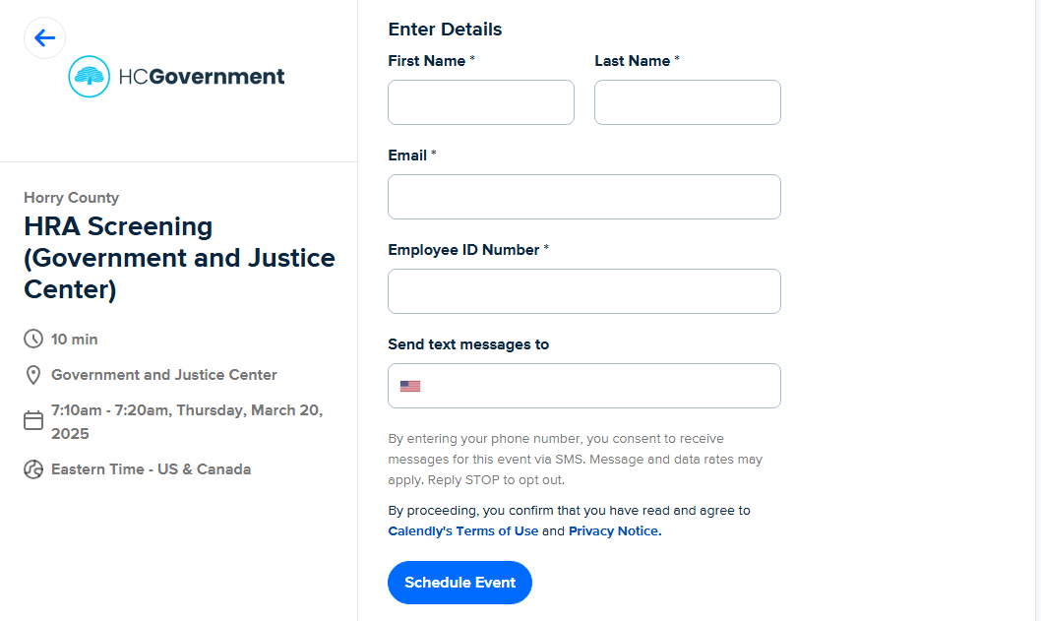

- You are scheduled. Please check your email confirmation for forms that will need to be filled out and brought to your appointment. If you have difficulty locating forms, please contact, Human Resources humanresources@horrycountysc.gov

